WELCOME

The Friendship Force of Western Michigan
is very happy
to welcome you to our special corner of Michigan.

We hope that you will enjoy your stay here in the
“Great Lakes State”
and learn a bit more about why we think this is a
wonderful area to live and explore.

Our club is divided among three communities in the
southwestern corner of the state of Michigan:

Grand Rapids
Holland
Kalamazoo
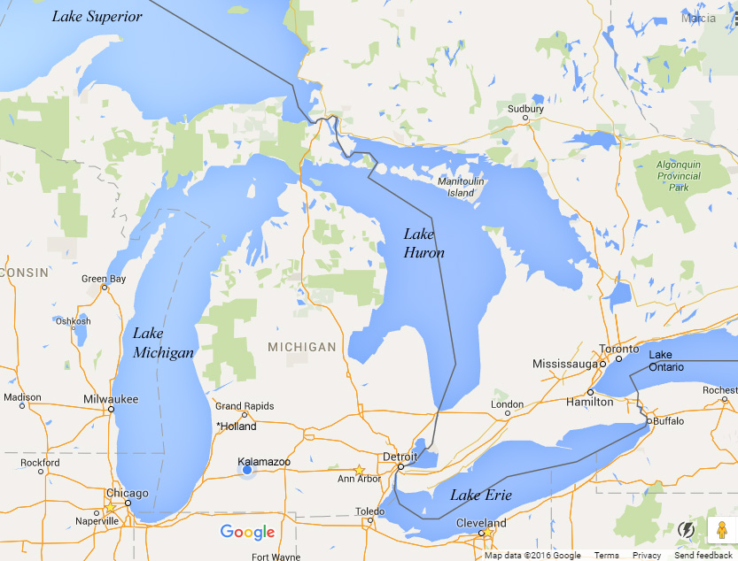

GRAND RAPIDS 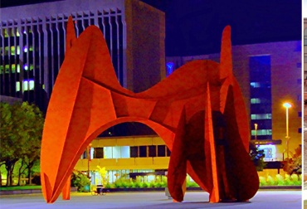

Grand Rapids is the second largest city in Michigan. The city has a population of about 188,000 but the surrounding communities bring the population to approximately 1,000,000.

The city sits on the banks of the Grand River at an altitude of 610 feet (186m) above sea level. It is approximately 30 miles (50 km) east of Lake Michigan. The state capital of Lansing lies about 60 miles (100 km) to the east by southeast, and Kalamazoo is about 50 miles (80 km) to the south.

Grand Rapids has long been a center for furniture manufacturing and is home to five of the world's leading office furniture companies. In the past it was called the "Furniture City" but now its more common mondern nickname is "River City" as it is located along the shores of the Grand River. There are many colleges and universities located in Grand Rapids, including the prestigious Kendall College of Art and Design. Other industries include health care, information technology, automotive, aviation and consumer goods manufacturing.

Grand Rapids is the hometown of the 38th U.S. president. He is buried with his wife, Betty, on the grounds of the Gerald R. Ford Presidential Museum.

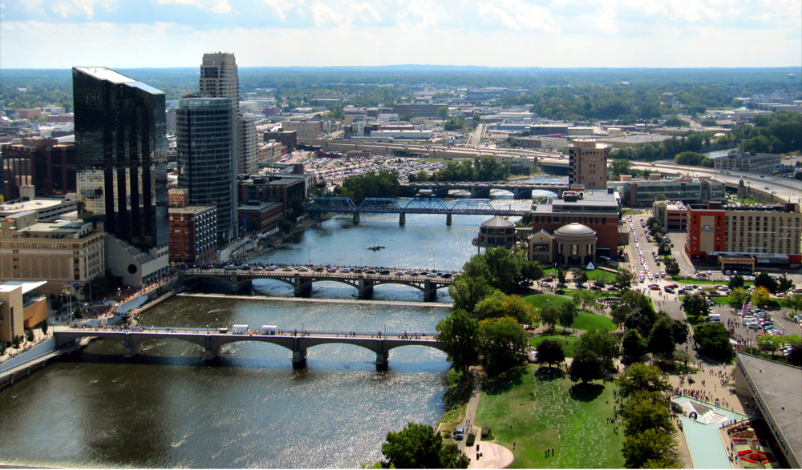

HOLLAND 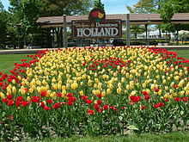

Holland is situated near the eastern shore of Lake Michigan. The population of Holland is approximately 33,000 residents.

Holland was settled in 1847 by Dutch Calvinist separatists who were escaping from persecution in the Netherlands. At the time, the land was inhabited by the Ottawa people who had been on the lake for hundreds of years. The native people moved north, under pressure from the new illnesses brought from the settlers.

Holland is known as the “City of Churches.” There are 170 churches in Holland, many of which are with the Reformed Church in America and Christian Reformed Church in North America denominations.

The city is perhaps best known for it’s Dutch heritage, which serves not only as part of the city’s cultural identity, but the local economy as well: the Tulip Time Festival in May and various Dutch-themed attractions augment the nearby Lake Michigan shoreline in attracting thousands of tourists annually.

Across the channel from Holland State Park on the shore of Lake Michigan is the Holland Harbor Light, known as “Big Red”.
DeZwaan, an original 250 year old Dutch windmill, is situated on Windmill Island, a municipal park.
Holland hosts an annual Tulip Time Festival each May. Tulip planting and the festival began in 1930 when 250,000 tulips were planted for the event. Today, 6 million tulips are used throughout the city.
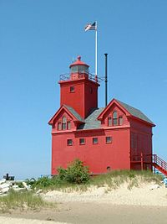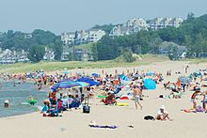

KALAMAZOO

Kalamazoo is the second largest city in southwestern Michigan. The city has a population of approximately 74,000, but with the surrounding areas the population is near 326,000.

The city is named for the Kalamazoo River, where it is situated mainly on the southwest bank of a major bend. There is debate as to where the name Kalamazoo actually comes from. It is generally thought the name originates in the language of either the Potawatomi or Ottawa peoples who were native to the area at the time of the European settlement.

The common phrase “from Timbuktu to Kalamazoo” resulted from the strange name, and has served to enter it into pop culture, and the name has been used in numerous songs. Probably the most recognized is “I’ve Got a Gal in Kalamazoo” made famous by the Glenn Miller Orchestra in the 1940s.

Kalamazoo is home to Western Michigan University, a nationally recognized research institution that has benefitted from the local presence of Pfizer pharmaceuticals, and the Eaton and Stryker Corporations

The city is also home to Kalamazoo College (often referred to as “K College”), a private liberal arts school located adjacent to WMU’s campus.

Because of very generous private donations from several anonymous individuals, every resident graduate of the Kalamazoo Public Schools is provided with a scholarship for up to 100% of tuition costs for four years at any public university or community college in Michigan.

Kalamazoo was once the home of Checker Cabs, Gibson Guitars and Shakespeare Rod and Reels. Though these last two still exist they are now manufactured in other lands. The A.M. Todd Company, one of the leading producers of peppermint oil and other favorings, is headquartered in Kalamazoo. Kalamazoo is also home to KalSEC, another flavorings company which was founded by another Todd family member.
